Session-7

1.Create a table called Restaurant with columns: id, name, location, and cuisine. Apply NOT NULL constraint to name and location, and make id the PRIMARY KEY.

Ans. CREATE TABLE Restaurant (
id INT PRIMARY KEY,
name VARCHAR(100) NOT NULL,
location VARCHAR(100) NOT NULL,
cuisine VARCHAR(50)
);

Output
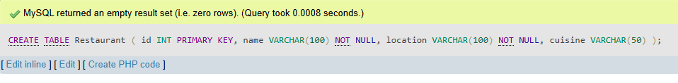

2.Create a table called FoodOrder with columns: order_id, restaurant_id, user_id, and order_total. Set order_id as PRIMARY KEY, and add a FOREIGN KEY constraint on restaurant_id referencing Restaurant(id).

Ans. CREATE TABLE FoodOrder (
order_id INT PRIMARY KEY,
restaurant_id INT,
user_id INT,
order_total DECIMAL(10,2),
FOREIGN KEY (restaurant_id) REFERENCES Restaurant(id)
);

Output
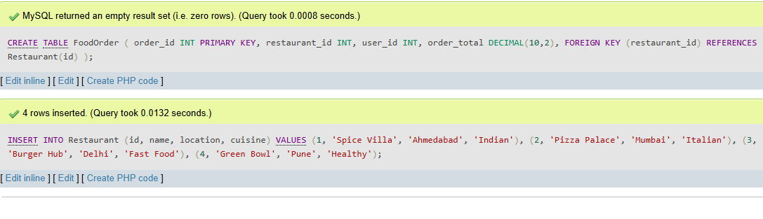

3.Insert 6 rows into a table called SpotifyUser with columns: user_id, username, email, and subscription_type. Ensure that username is UNIQUE and email is NOT NULL.<br><br><em><strong>Hint:</strong> Use the UNIQUE and NOT NULL constraints when creating the table.</em>
Ans
INSERT INTO SpotifyUser (user_id, username, email, subscription_type)
VALUES
(1, 'om123', 'om@gmail.com', 'Premium'),
(2, 'riya45', 'riya@gmail.com', 'Free'),
(3, 'rahul99', 'rahul@gmail.com', 'Premium'),
(4, 'neha07', 'neha@gmail.com', 'Student'),
(5, 'amit88', 'amit@gmail.com', 'Premium'),
(6, 'pooja21', 'pooja@gmail.com', 'Free');

Output
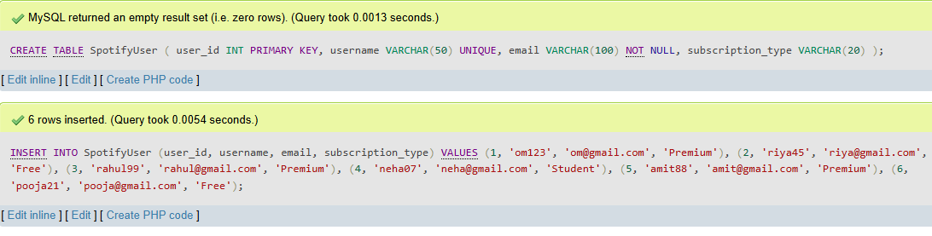

4.Create a VIEW named TopSpendersView that shows usernames and order_total from a FoodOrder table where order_total is greater than 1000.

Ans
CREATE VIEW TopSpendersView AS
SELECT
s.username,
f.order_total
FROM FoodOrder f
JOIN SpotifyUser s
ON f.user_id = s.user_id
WHERE f.order_total > 1000;
Output
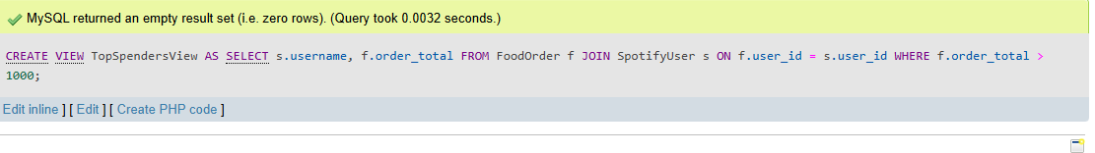

5.Write a SQL query to list all users from the TopSpendersView who have spent more than 2000, sorted by order_total descending.<br><br><em><strong>Constraint:</strong> Only use the TopSpendersView for your query, not the original FoodOrder table.</em>

Ans SELECT *
FROM TopSpendersView
WHERE order_total > 2000
ORDER BY order_total DESC;

Output
